**Lab Tasks for Lab no. 4**

**LAB 4.1 Opening, Compiling and Running Your First Program**

Exercise 1: Compile the program.

Exercise 2: Run the program and write what is printed on the screen.

The code is as follows:

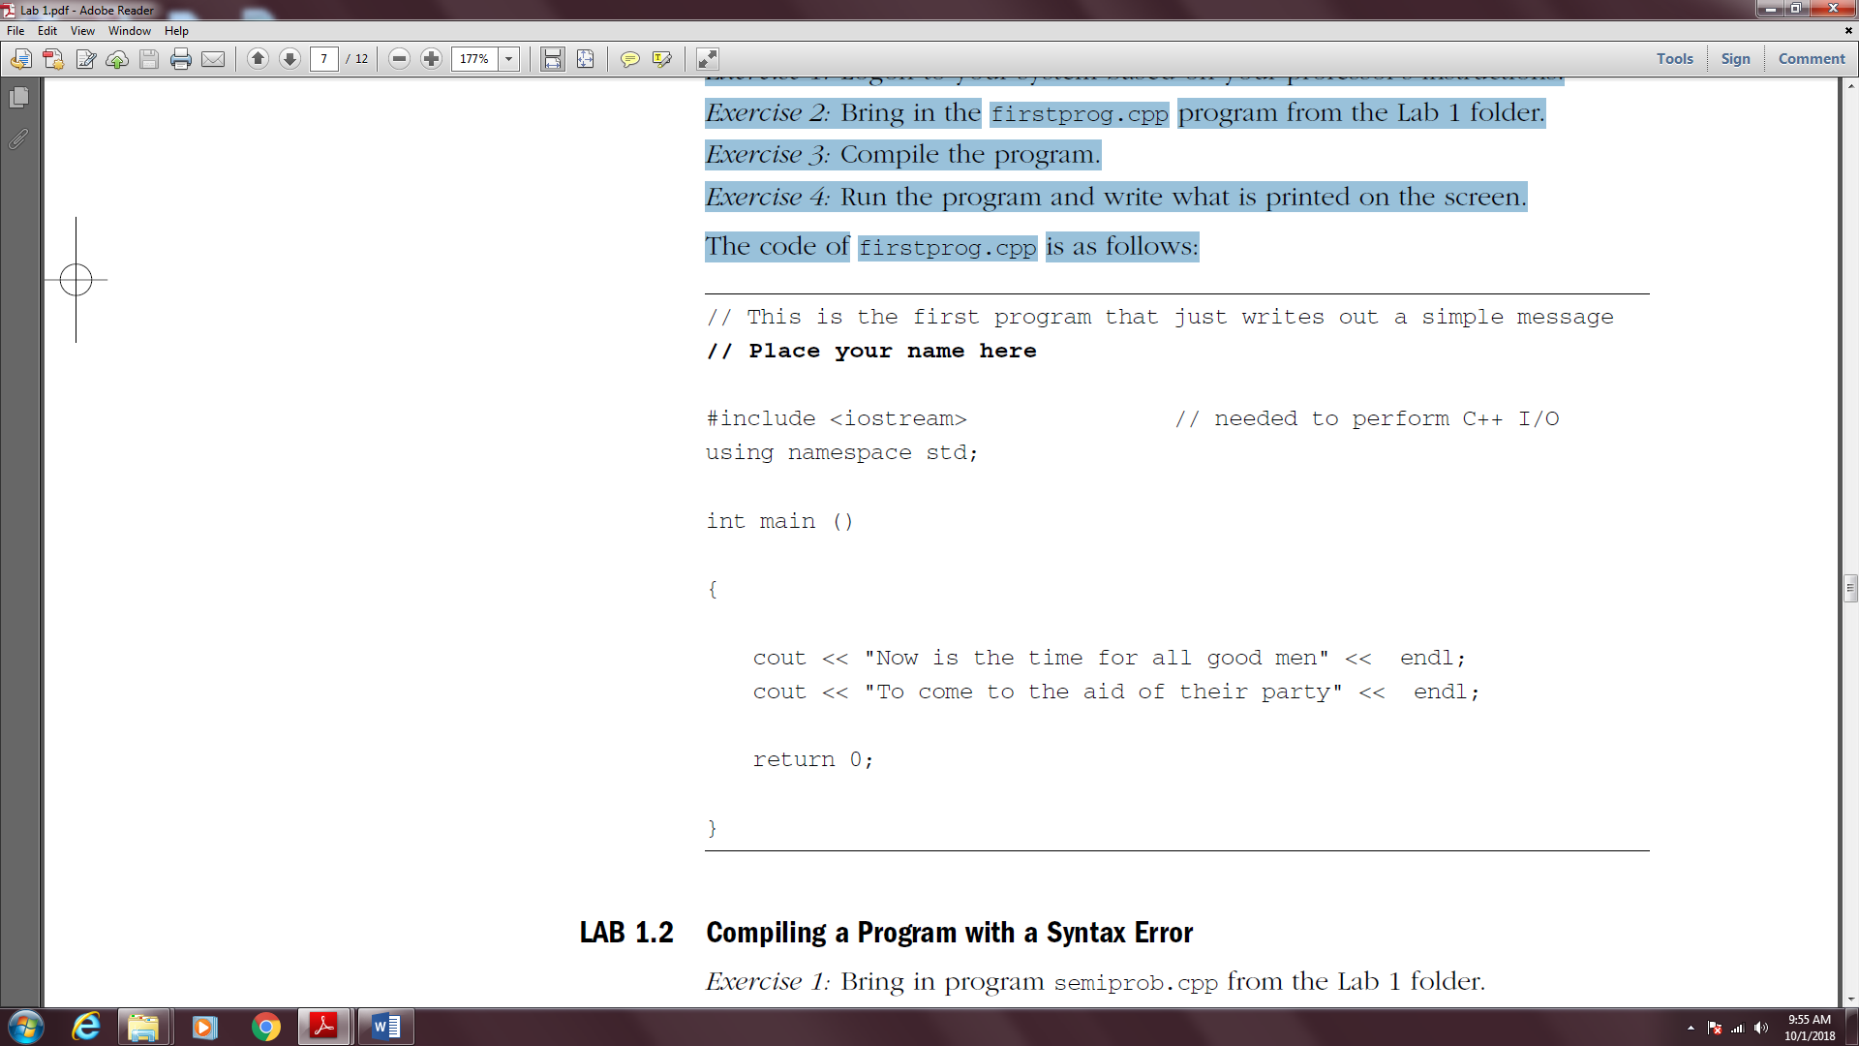

**LAB 4.2 Compiling a Program with a Syntax Error**

Exercise 1: Compile the program. Here we have our first example of the many syntax errors that you no doubt will encounter in this course. The error message you receive may be different depending on the system you are using, but the compiler insists that a semicolon is missing somewhere.

Unfortunately, where the message indicates that the problem exists, and where the problem actually occurs may be two different places. To correct the problem place a semicolon after the line cout << "Today is a great day for Lab".

Most syntax errors are not as easy to spot and correct as this one.

Exercise 2: Re-compile the program and when you have no syntax errors, run the program and input 9 when asked. Record the output.

Exercise 3: Try running it with different numbers. Record your output.

The code of semiprob.cpp is as follows:

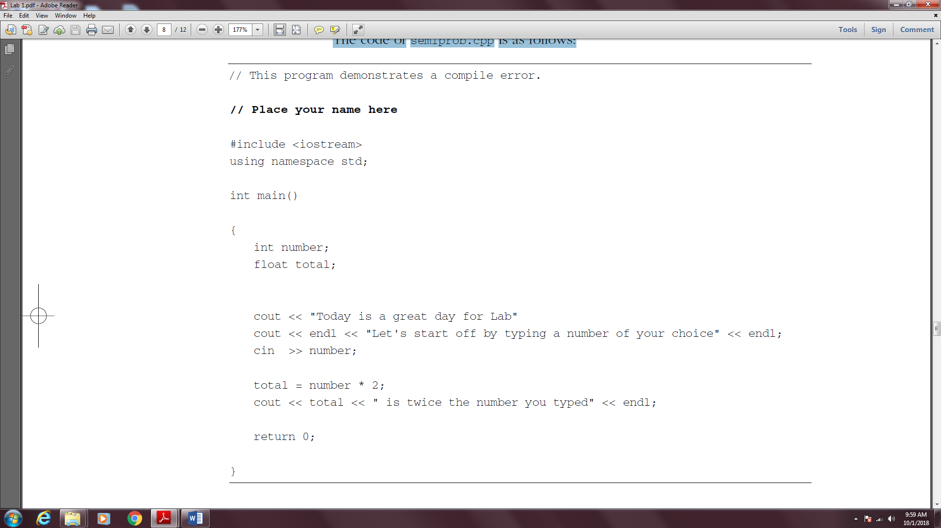

**LAB 4.3 Running a Program with a Run Time Error**

Exercise 1: Compile the program. You should get no syntax errors.

Exercise 2: Run the program. You should now see the first of several run time errors. There was no syntax or grammatical error in the program; however, just like commanding someone to break a law of nature, the program is asking the computer to break a law of math by dividing by zero. It cannot be done. On some installations, you may see this as output that looks very strange. Correct this program by having the code divide by 2 instead of 0.

Exercise 3: Re-compile and run the program. Type 9 when asked for input.

Record what is printed.

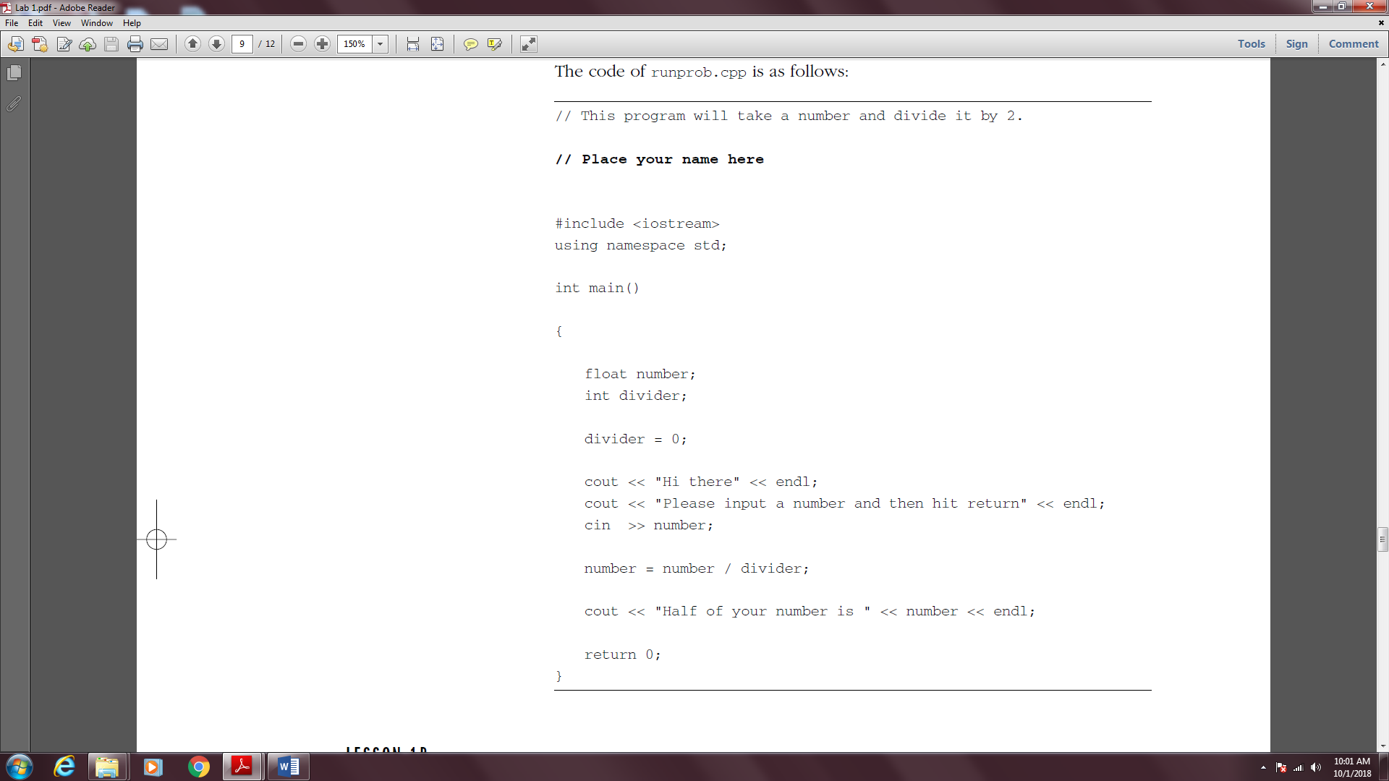

**LAB 4.4 Working with Logic Errors**

*Exercise 1:* Compile this program. You should get no syntax errors.

*Exercise 2:* Run the program. What is printed?

*Exercise 3:* This program has no syntax or run time errors, but it certainly has a logic error. This logic error may not be easy to find. Most logic errors create a challenge for the programmer. Your instructor may ask you not to worry about finding and correcting the problem at this time.

